Richard C. Belthoff, Jr.
Home: Office: Fax: Email: com

May 7, 2013

Town & Country Toyota
9101 South Blvd
Charlotte, NC 28273

Re: Deal:
STK:
Cust:
GAP:

Dear Town & County Toyota:

Pursuant to Section F of the EasyCare Gap Gold Difficiency Waiver Addendum referenced above, please cancel my Gap policy effective as of May 6, 2013, as I traded in my Highlander for another vehicle. The Southeast Toyota Finance loan on the vehicle will be paid off so any refund should be sent to my attention.
Thank you.
Very truly yours,
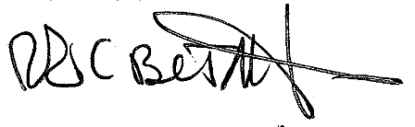

Richard C. Belthoff, Jr.

