I recently reinstalled Windows 7 on my system and after doing all the updates, and against my better judgement, installing the latest update rollup, which I knew contained a notification system about the upcoming end of support for Windows 7 (read, a nagging utility to bug you until you cave and install Windows 10 so they can start monitoring, tracking and keylogging everything you do on your PC for their own profits).

Well, I was doing one of my usual tasks setting up my computer on a fresh Windows install of going through Task Scheduler and eliminating or disabling any items I don't want running in the background and lo and behold, a new entry was discovered pointing to a new executable that resides in the System32 folder called **sipnotify.exe** that uses the Windows 7 logo/flag as its icon, and the entries (of which there are 2, not just one) in Task Scheduler provide the following rather illuminating description for the location of the item:

**\Microsoft\Windows\End Of Support**

So I'm sure you can guess what this utility's purpose is.  And just in case you can't, I'll tell you.  It is there simply to inform you that your version of Windows is no longer supported and to urge you to upgrade to the latest version of Windows, i.e. Windows 10.  Once the fateful day of January 14th rolls around next year, I'm sure this little executable is going to be very busy:

[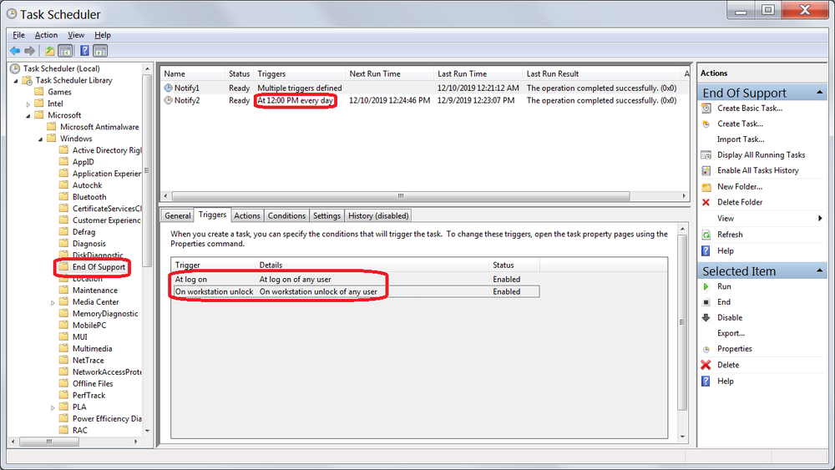](https://content.invisioncic.com/Mmalware/monthly_2019_12/End.png.8ab7a4185f87799a332a5c6cef118707.png)

It is scheduled to launch every time anyone logs onto the machine, any time anyone unlocks the machine for any user account, and if that isn't enough to 'persuade' people to upgrade, it is also scheduled to run at 12:00 PM every single day.

Needless to say I will be deleting these scheduled tasks as I have no use for them.  I don't need Microsoft to tell me that my operating system is over 10 years old and is no longer supported and that my only option, if I wish to continue using Windows, is to either install their new, bloated, secretive, spying, unconfigurable operating system known as Windows 10 or to continue running the same reliable, secure, much more privacy and user control focused version of Windows that they will no longer be providing patches for (and rightly so, 10 years is a long time in the software world so I don't expect them to continue to support it or to dedicate any developer resources to it; I just want them to leave me alone so that I can continue to use the operating system I prefer in peace).

Originally this utility was rolled out in update package **KB4493132**, however now that Microsoft has been bundling updates in monthly rollups, the level of control over which patches will and will not get installed on your system has pretty much vanished.  This is yet another 'improvement' that shows just how focused Microsoft is on putting control over things into the hands of their customers and incidentally is identical to the tactics used by PUP vendors to sneak in unwanted programs and add-ons with legitimate software installers; something Malwarebytes flags as PUP more often than not as illustrated by the search results on their online threat database [**here**](https://blog.malwarebytes.com/?s=bundle), however I don't expect them to start flagging any Windows Updates as threats any time soon, though if Microsoft continues with these sneaky tactics someone may have to.

You can learn more about this issue by reading BleepingComputer's article on the subject [**here**](https://www.bleepingcomputer.com/news/microsoft/kb4493132-update-notifies-windows-7-users-of-end-of-support-date/) as well as How-To Geek's writeup on it [**here**](https://www.howtogeek.com/408556/how-to-avoid-windows-7s-end-of-support-nags/).  Those articles are a bit outdated now that the patch has been bundled into the monthly rollups but is still relevant to understanding what this is what it is for.

Thankfully the notifications can be disabled, either by editing the scheduled tasks (which is what I'm going to do; I'll simply delete them) or by using the checkbox to disable future notifications about it once the first notification shows up.

It doesn't so much bother me that Microsoft is informing users about the end of support for Windows 7 as much as it bothers me that they falsely claim that 10 is a superior alternative.  If Microsoft were to offer an option for a version of Windows without all the embedded telemetry, spyware and advertising that doesn't wrestle control of the OS from its users and place them squarely into the hands of the OS itself and its developers, especially one that actually looks like a modern operating system rather than a flat, featureless, lazy design that resembles a UI mockup more than an actual functional UI, I'd be all over it.  The promise of Longhorn died with Vista, but its spirit was resurrected in the OS that followed called Windows 7, and ever since then Microsoft has been falling all over themselves trying to be just like Apple and Google instead of remembering how to be themselves.  Microsoft has done some great things in the past and they've given us some astonishing software, unfortunately I just can't count Windows 10 among the better ones and that's unfortunate, especially considering the fact that Microsoft has stated that 10 is to be the last version of Windows.  I'm sure there will be changes and 10 may some day get a nice facelift and might even adopt some of the user-centric philosophies I praise so much in Windows 7, and if that day comes I will certainly make the switch, but until then it is full steam ahead with Windows 7 into the unknown future for me.