 | September in the Rain 1965
 | Chad & Jeremy
 | Dream a Little Dream of Me 1950
 | Louis Armstrong & Ella Fitzgerald
 | Hello, Young Lovers 1955
 | Jimmy Durante
 | When I Grow Too Old to Dream 1947
 | Nat King Cole
 | Sweet Dreams 1963
 | Patsy Cline
 | Maria Elena 1959
 | Jim Reeves
 | Petite Waltz 1955
 | Chet Atkins
 | A Fool Such as I 1953
 | Tommy Edwards
 | When 1958
 | The Kalin Twins
 | Summer Wind 1966
 | Frank Sinatra
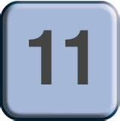 | I Can Dream, Can’t I? 1949
 | The Andrews Sisters
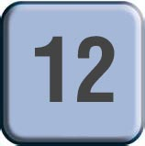 | Moon River 1964
 | Louis Armstrong
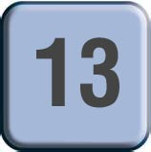 | Singin’ in the Rain 1952
 | Gene Kelly
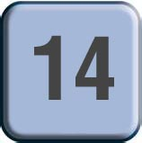 | The Way You Look Tonight 1961
 | The Lettermen
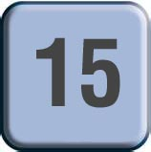 | Over the Rainbow 1939
 | Judy Garland
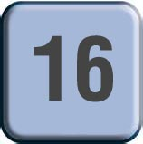 | Memories of You 1938
 | Benny Goodman Orchestra

